**Installing VNM Flash**

1. **Download Update tools from**

<https://vnmsimulation.com/download>

click download ZIP

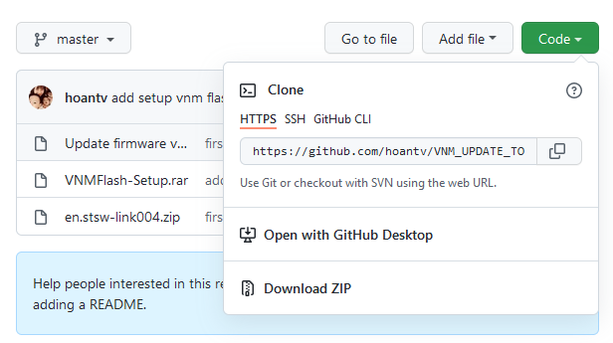

1. **Enable DFU Mode for VNM products**

* There are a few ways to enable DFU mode for VNM products.

+ If it is a button (on the back of shifter, on the side of a handbrake):

- Push it and leave in **high position**, then remove and reconnect usb cable.

+ If it is a switch (on the back of shifter, on the side of a handbrake, on the pedal box, ffb controller box):

- Toggle switch to DFU, then remove and reconnect usb cable.

1. **Install software and driver**

Open downloaded ZIP file -> open VNMFLASH-Setup.rar -> click Setup.exe and do as following:

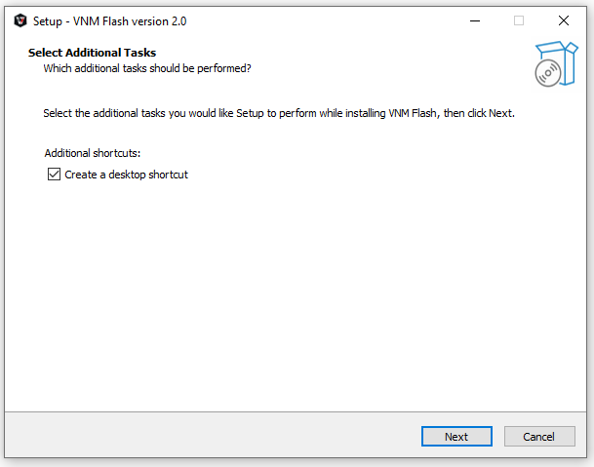

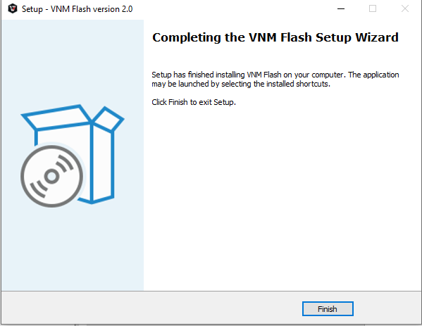

**Firmware Upgrade**

* **Run VNM Flash as administrator**

Depending on type of device, it will show up differently in **Device Info**.

If MCU is **Cortex-M4**, it will show “**STM32 BOOLOADER**”.

If MCU is **Cortex-M7**, it will show “**DFU in FS Mode**”.

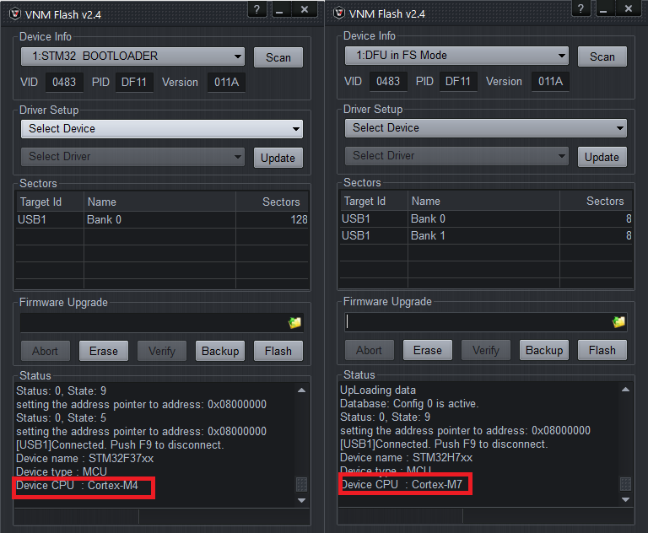

**For Cortex-M7 MCU**

* Proceed to erase existing firmware by clicking **Erase**. Once completed, the **Status** will display the following:

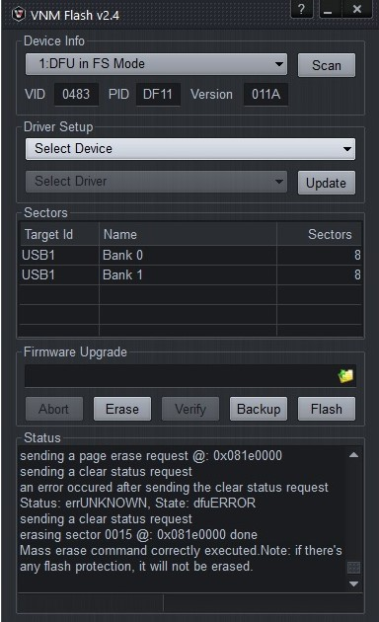

* **IMPORTANT**: Download required firmware files and place in the same folder as shown below.

These 3 files are required for firmware upgrade to function properly.

* xxxxx**.hex**
* xxxxx**.dfu**
* xxxxx**.signed.dfu**

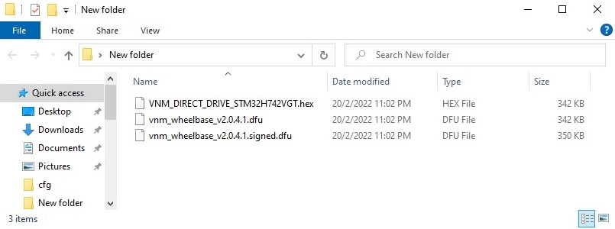

* Click on the **folder icon** beside **Firmware Upgrade** and select the **xxxxx.signed.dfu** file.

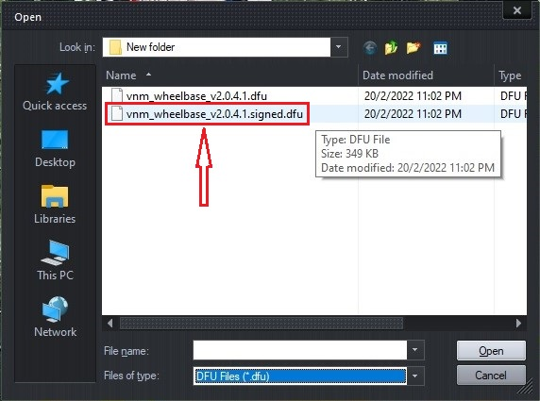

* Click on the **Flash** to perform firmware upgrade. Once completed, the **Status** will display the following:

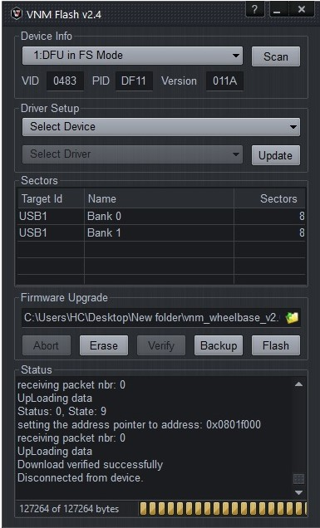

**For Cortex-M4 MCU**

Do the following steps:

In Driver Setup, select a device that show in the select device combo box, select “STM32 Device in DFU Mode” in select driver combo box, click update.

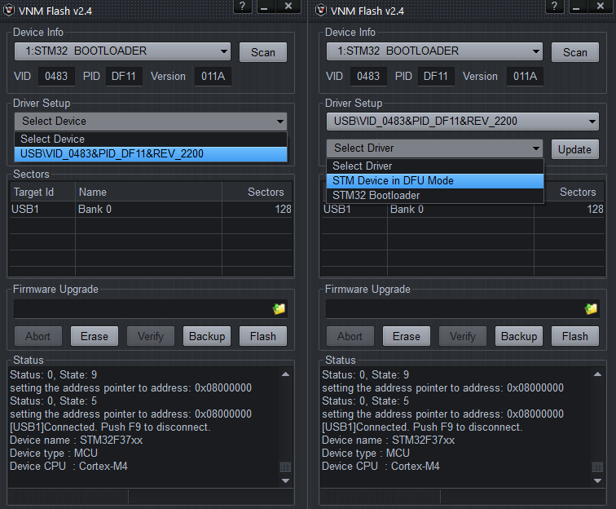

After in the console log shows “Drivers installed successfully. Please replug your device!” => reconnect device and now you can upgrade a firmware for the device

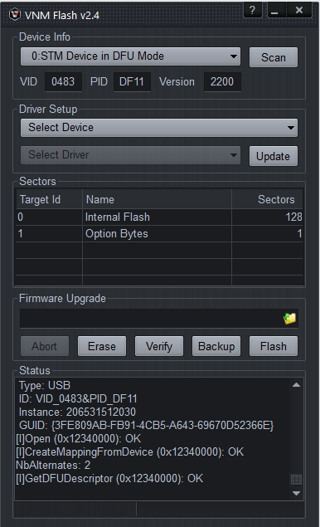

1. **Upload firmware**

* Click Erase firmware

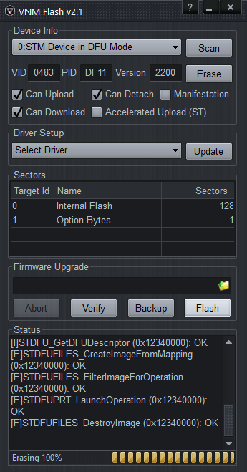

Browse to a firmware file which you want to install. The file name must contain “signed.dfu”.

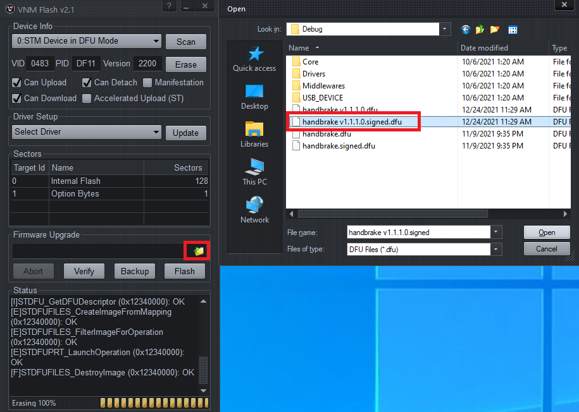

Click “Verify”, if result is OK, the firmware file is good.

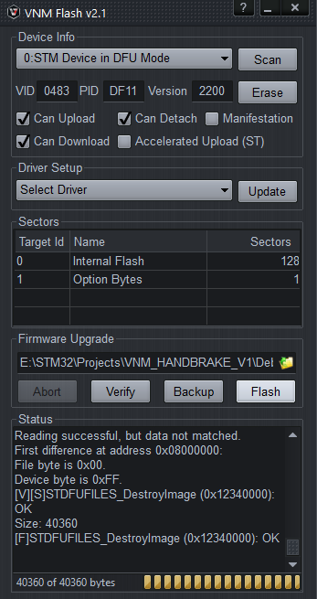

Click “Flash” and wait until it be loaded to the device.

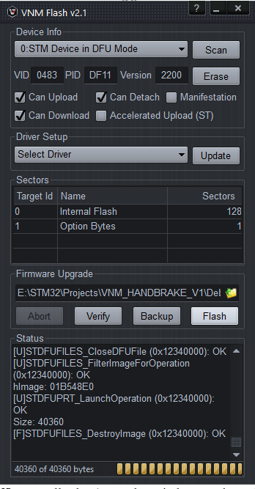

1. **Get out of DFU mode**

Rollback the step 2

+ If it is a button (on the back of shifter, on the side of a handbrake): Push it and let it in low state, reconnect usb cable.

+ If it is a switch (on the back of shifter, on the side of a handbrake, on the pedal box, ffb controller box): toggle switch to work mode and reconnect usb cable.

Now finish 😊!